*SANJESH S V (711519BEC094)*

**Assignment 1 :**

**The data Virtualisation for the given data set with setting Profit as target with multiple factor such as**

1. R&D spending:
2. *Administration spending:*
3. *Marketing spending*
4. *State*

***Screenshots for the data exploration :***

***Profit by state :***

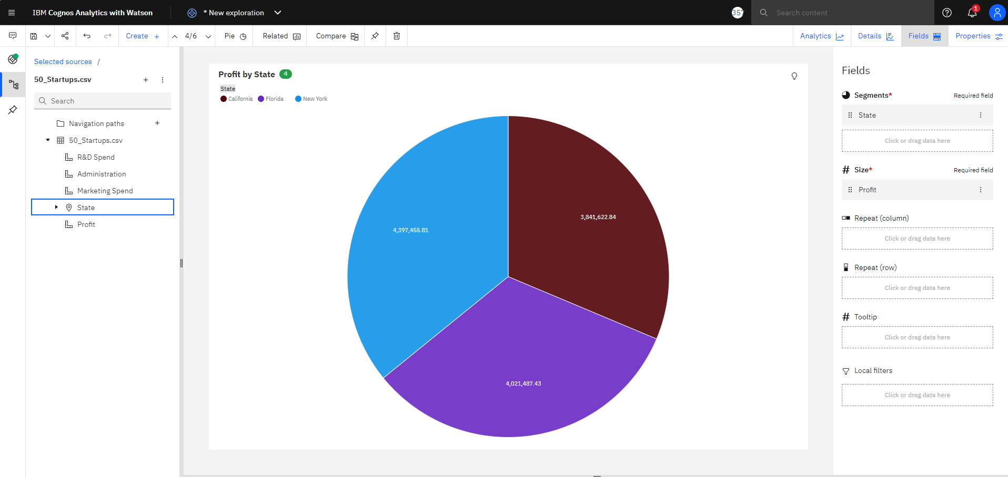

**Profit by Administration vs Profit by R&D Spending :**

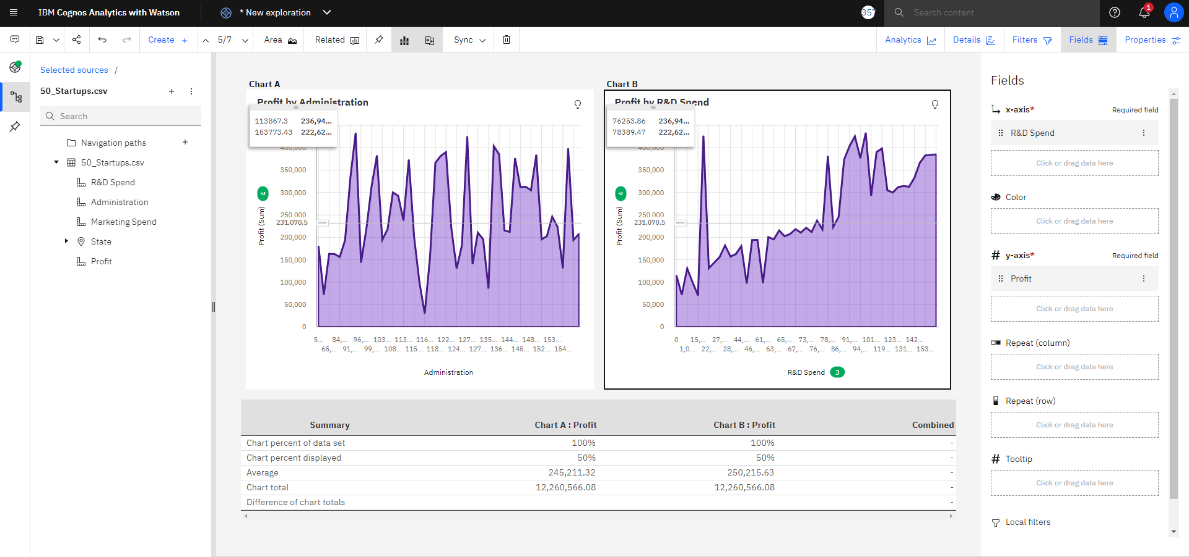

**Profit by R&D spending :**

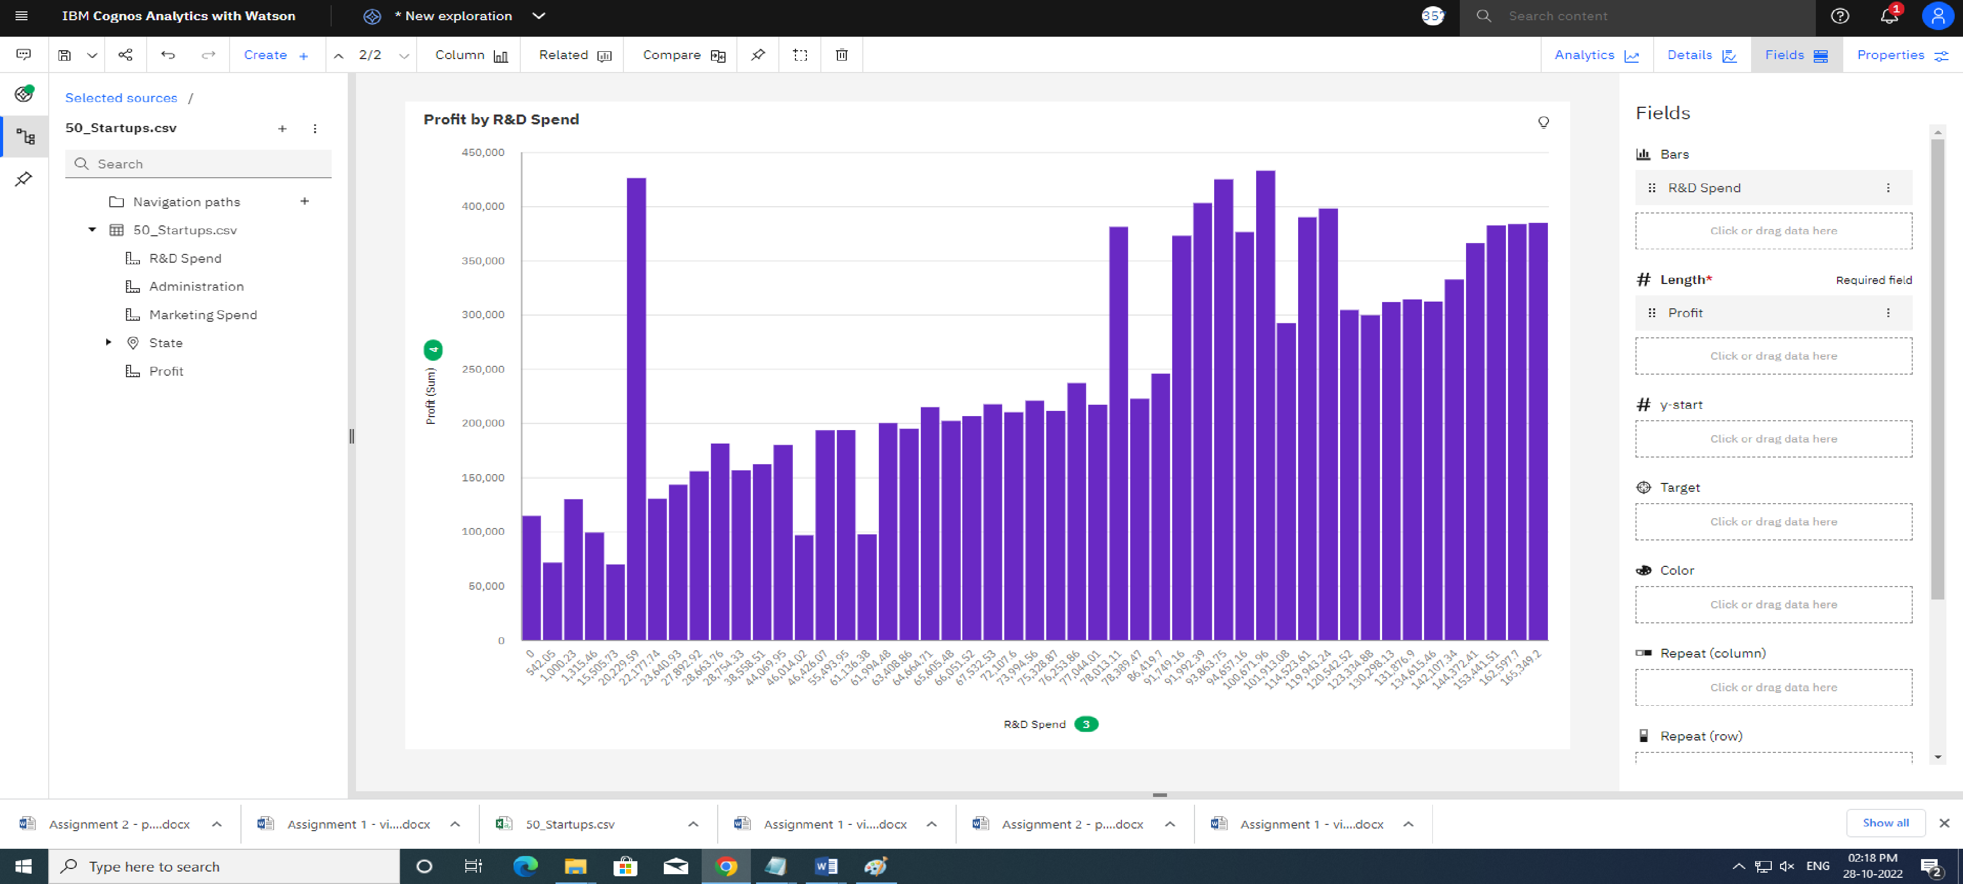

**Profit by Administration :**

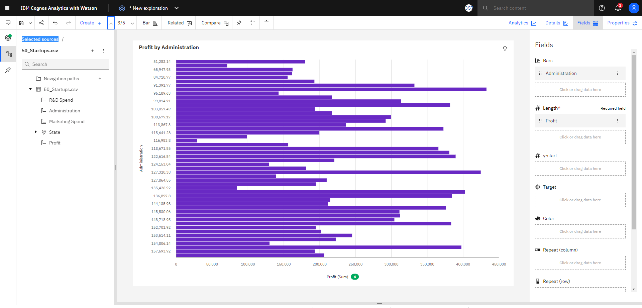

**Profit by marketing spend** :

